SE4092 Final Year Project – II

DDoS Detection in Kubernetes using ML and DL

Submitted By
Asher Siddiqui 21K-3860
Mahnoor Amjad 21K-3884
Rija Anwar 21K-3069

Project Progress Report
Department of Software Engineering
National University
Of Computer and Emerging Sciences
FAST Karachi Campus
1. INTRODUCTION
With the rising adoption of cloud native applications & micro-service architectures, Kubernetes has gained sufficient notability as a container orchestration platform that deploys micro-services as per user/customer demand. However, it is prone to DoS and DDoS attacks made vulnerable by its scalability and flexibility issues just like any other online system is, but what makes it harder to detect is its distributed nature. This leads to severe service disruptions, loss of revenue, & compromised customer trust.
Classical machine learning has been employed for anomaly detection in cloud and containerized environments. Deep learning has been tried in detecting DoS/DDoS attack patterns. Challenges, however, remain in terms of real-time detection, scalability, minimizing false positives, and adapting to evolving attack patterns.
Our efforts aim to combine the logic of ML and DL to detect anomalous behavior that is indicative of DoS/DDoS attacks on cloud native applications through a feature collection technique tailored to Kubernetes.
2. TIMELINE
FYP Timeline is followed as is, no changes were incurred as we completed all our tasks on time.

3. PROGRESS
Following modules cover our progress from the final of last semester to the midterm of this one.
3.1 MILESTONE 1 PROGRESS - CODEBASE
A) CENTRAL MODULE
For FYP–II, we implemented a dataflow aggregator to collect and average data from multiple nodes. This functionality was essential for consolidating system metrics and improving analysis efficiency.
The aggregator was partially implemented and integrated within another script; the lab simulation script developed in FYP-1. While the core functionality is in place, further refinements are required for full optimization.

B) AGENT SERVICE
We completed this module right in FYP–I. We deployed a local Kubernetes cluster comprising four nodes (1 master and 3 worker nodes) using an Ansible script. Each worker node was equipped with 16GB DDR5 RAM and a 16-core Intel Core i7 (12th Gen) processor. The cluster utilized Calico as the networking plugin and MetalLB for load balancing.
A three-node botnet, controlled by a command-and-control (C2) server, was configured to simulate various types of traffic. The C2 server dispatched commands to the botnet, enabling it to dynamically alternate between attack types. The botnet maintained process IDs of launched binaries to terminate previous attacks before initiating new ones.
We developed a simulation script which alternated randomly between six traffic modes; HTTP Flood, UDP Flood, TCP Flood, ICMP Flood, Normal Traffic and High Traffic. Each mode was chosen as they produced the most varying changes in the system calls and resource metrics under different attack conditions which made it easier for the models to classify the attack type and were run for a randomly selected duration of 180 to 300 seconds. For attacks, we used hping3 to generate UDP, TCP, and ICMP floods, and goldeneye.py for HTTP floods. Normal traffic simulated 50 concurrent connections, while high traffic simulated 200 concurrent connections, with ramp-up, sustain, and cool-down phases.
To provide a realistic target for these attacks, we deployed an intentionally vulnerable, open-source microservices-based e-commerce website, Juice Shop, on the Kubernetes cluster. This service was the primary target of TCP and HTTP floods, specifically targeting port 80.
Metrics were collected every second from all three worker nodes, resulting in approximately 16MB of data, with over 55,000 rows.
MILESTONE 2 PROGRESS - MODELS
In FYP–I, we implemented multiple machine learning models using a 90-10 train-test split and evaluated them with 5-fold cross-validation. Based on the research gap, the primary focus was on Random Forests, but additional models were implemented for the sake of comparison as the accuracy of Random Forests raised concerns about potential overfitting due to excessively high performance.
Random Forests achieved 99% accuracy. Decision Trees achieved 95% accuracy. Support Vector Machines (SVM) and Logistic Regression scored an accuracy below 50%. Results indicated that tree-based models (Random Forests and Decision Trees) outperformed non-tree-based models, aligning with the hierarchical nature of the collected metrics and the complex relationships between features.
The tree-based models significantly outperformed other approaches, with Random Forest achieving the highest accuracy at 99%. This was validated through multiple metrics including F1-score, recall, and testing time. The performance of tree-based models suggests they are good for DDoS attack classification using system calls and resource metrics.
For FYP–II, we worked with two deep learning models—Gated Recurrent Unit (GRU) and Long Short-Term Memory (LSTM)—for the detection of DDoS attacks in a cloud-native Kubernetes environment. Our dataset initially included a broad set of system-level metrics, which we later refined to improve model performance.
The models were trained for 20, 50, and 100 epochs, yielding the following accuracy results:
LSTM: 92% (20 epochs), 94% (50 epochs), 95% (100 epochs)
GRU: 91% (20 epochs), 94% (50 epochs), 95% (100 epochs)
Initially, the dataset consisted of multiple features which are compiled below:
- CPU Metrics: node_cpu_seconds_total
- Memory Metrics: node_memory_MemAvailable_bytes, node_memory_MemTotal_bytes
- Network Metrics: node_network_receive_bytes_total, node_network_transmit_packets_total
- Disk Metrics: node_disk_read_bytes_total, node_disk_written_bytes_total
- System Load Metrics: node_load1, node_load5, node_load15
- TCP/UDP Statistics: node_sockstat_TCP_inuse, node_sockstat_UDP_inuse
- Syscall Activities: mmap, munmap, accept, brk, bind, connect, chdir, clone, close, kill, listen, mkdir, open, poll, read, rename, recvfrom, select, socket, sendto, write
However, our later research showed that four features—node_sockstat_TCP_inuse, node_sockstat_UDP_inuse, node_network_receive_errs_total, and node_netstat_Tcp_CurrEstab—contributed absolutely nothing and exhibited a straight-line trend over time. These features were removed, leading to a slight improvement in model accuracy.
Post feature selection, both models demonstrated an increase in accuracy:
- LSTM: 94% (20 epochs), 95% (50 epochs), 96% (100 epochs)
- GRU: 94% (20 epochs), 95% (50 epochs), 95% (100 epochs)

Below are the confusion matrices of LSTM and GRU respectively, defining the above explained output.
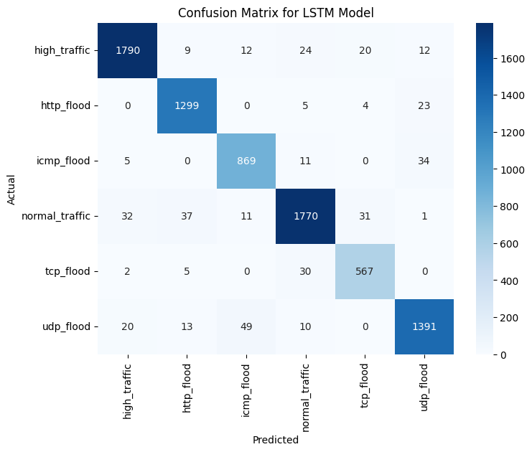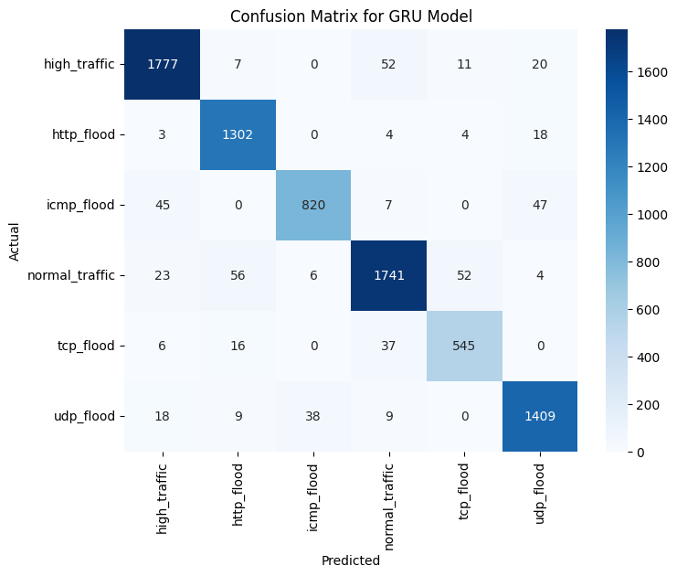

MILESTONE 3 PROGRESS - RESEARCH PAPER
In FYP–I, we drew out the outline of our research paper. We did our due diligence on the materials we found on ML and DL models dealing with DDoS and anomalous behavior in Kubernetes. The research gap was evaluated and we identified our scope upon which we have built so far. Provided below is the summary of our findings so far.
1. Machine Learning Approaches
Hierarchical Systems
Anemogiannis proposed a hierarchical anomaly detection method that uses baseline metrics for Kubernetes resources, scoring anomalies based on severity for efficient resolution.
Supervised Learning
Du et al. employed supervised ML models (e.g., SVM, Random Forest, k-NN) to classify system behavior, improving anomaly detection through fault injection and time-series analysis.
Optimized Isolation Forests
Zou et al. enhanced anomaly detection by weighting resource metrics and adjusting monitoring intervals, improving real-time detection while reducing overhead.
2. Deep Learning Approaches
Hybrid Models
Tien et al. combined CNNs and RNNs to identify both spatial and temporal patterns in Kubernetes resource metrics, achieving 96% detection accuracy.
Auto-encoders
Lin et al. introduced a classified distributed learning model using auto-encoders to detect attacks through reconstruction errors, tailored to application-specific behaviors.
Self-Organizing Maps
Forsberg applied unsupervised learning for dimensionality reduction and root-cause analysis, enhancing anomaly detection through dependency graphs and anomaly alignment.
3. Combining ML and DL
Harlicaj proposed a two-stage approach: classical ML for baseline anomaly detection and DL (e.g., RNN or CNN) for identifying complex, multi-step attack patterns, leveraging the strengths of both techniques.
4. Our Scope
The paper by Darwesh et al. forms the basis for this project, introducing a novel feature collection technique and hierarchical anomaly detection system tailored to Kubernetes. It combines Isolation Forests for efficient detection of high-dimensional anomalies and LSTM networks for time-series analysis. Building upon this framework, our project aims to enhance real-time monitoring and accuracy while reducing false positives, aligning with Kubernetes' layered architecture.

Updated Timeline
FYP Calendar is followed as is for the timeline as no new changes have been made.

References
- Anemogiannis, M. (2023). Hierarchical anomaly detection strategy for Kubernetes resources.
- Du, M., et al. (2018). DeepLog: Anomaly Detection and Diagnosis from System Logs through Deep Learning.
- Zou, H., et al. (2019). Docker container anomaly monitoring system based on optimized isolation forest algorithm.
- Tien, C. W., Liao, J. W., Chang, S. C., & Kuo, S. Y. (n.d.). KubAnomaly: Anomaly detection for the Docker orchestration platform with neural network approaches.
- Lin, Y., Tunde-Onadele, O., & Gu, X. (n.d.). CDL: Classified Distributed Learning for Detecting Security Attacks in Containerized App.
- Forsberg, J. (2022). Automatic anomaly detection and root cause analysis for microservice clusters.
- Harlicaj, E. (n.d.). Anomaly Detection of Web-Based Attacks in Microservices.
- Darwesh, G., Hammoud, J., & Vorobeva, A. A. (n.d.). A novel approach to feature collection for anomaly detection in Kubernetes environment and agent for metrics collection from Kubernetes nodes.

